User Guide – ESG TAXONOMY AUTOMATED CALCULATION

Autor: Justyna Kmiecik

Fast Data Consulting

Content

Introduction 1

Solution Design 2

Data Sources 4

Preparing your Environment 5

1. Installation of OCMT – Oracle Client for Microsoft Tools 5

2. Installation of Oracle ODAC – Oracle Data Access Components 5

3. Setting Up Oracle Database Access in your Excel 6

Functionalities of this Tool 8

1. Refresh Data 8

2. Check the Portfolio 9

3. Understand Calculations for Each MSCI ESG Data Attribute 10

Maintenance of this Tool 12

1. Add new Custom Field 12

Error Handling 14

1. Timeout Error 14

2. Slow Loading of Data (when data are refreshed) 15

3. Delete Cache 15

# Introduction

The goal is to Integrate the MSCI ESG attributes into the existing query for each fund and issuer to ensure that comprehensive ESG data is included in the output. The calculations must be made at two levels: **at the fund level** and **at the issuer level**. A special calculation is required to determine the total result, considering the % of Fund’s volume (attribute “% am FV”). Two goals:

* Ensure that all relevant ESG attributes from the MSCI ESG data sources are appropriately linked to the main dataset to enrich the available information for each fund and issuer.
* Include attributes in the mapping table – the mapping table translate which MSCI Data Points are

# Solution Design

After analyzing the business and technical requirements, we have decided to build this Solution using Power Query in Excel as the main transformation tool, connected directly to DWH (Datawarehouse – REPO.UI.NET).

Current version of this Tools is saved here: ***N:\Projekte\***

See Page 3.

Ein Bild, das Text, Screenshot, Diagramm, Schrift enthält.

Graph 1 – Solution Design – ESG Taxonomy

# Data Sources

Data Source for this Dashboard include Tables from Datawarehouse (MSCI Data Dictionary) and Mapping Table that translate ESG Taxonomy Questions into MSCI Data Attributes.

See the Sheets Attached (based on last available Version *Automated_ESG_Calculation_V2.3*)

Ein Bild, das Text, Screenshot, Software, Webseite enthält.

|  |  |
| --- | --- |
| TAB-Name | Comment |
| START | insert Parameters: FUND_ID; VALUATION_DATE |
| PORTFOLIO | List of current items / securities listed for this Fund and timeframe. It is a basis for calculations. |
| GET_MSCI_DATA DISCTIONARY | Data Dictionary with Data Types and Field explanation |
| ESG_TAXONOMY_FRAGEN | Questions from ESG Taxonomy - Mapping Table |
| MAPPING_ISSUER_LEVEL | Results for Each MSCI Field |

# Preparing your Environment

To use this Dashboard, it is important to prepare your Local Environment and install necessary Tools.

## Installation of OCMT – Oracle Client for Microsoft Tools

Please refer to Documentation [here](https://docs.oracle.com/en/database/oracle/oracle-data-access-components/19.3.2/ocfmt/using-oracle-client-microsoft-tools.pdf).

It is required to install OCMT before using this Dashboard. Please open USO Ticket ([here](https://serviceportal.universal-investment.com/vmweb/vmweb)). After IT Administrator installs it for you, go to Software center and install on your local machine.

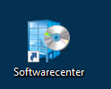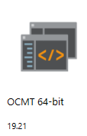

## Installation of Oracle ODAC – Oracle Data Access Components

Please refer to Documentation [here](https://www.oracle.com/database/technologies/odac-downloads.html).

It is required to install OCMT before using this Dashboard. Please open USO Ticket ([here](https://serviceportal.universal-investment.com/vmweb/vmweb)). After IT Administrator installs it for you, go to Software center and install on your local machine.

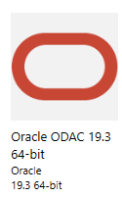

## Setting Up Oracle Database Access in your Excel

Before your first use, please insert Password for REPO.UI.NET in the Database Settings:

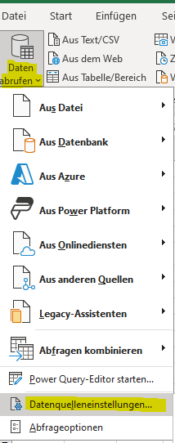

Ein Bild, das Text, Screenshot, Software, Computersymbol enthält.

Ein Bild, das Text, Screenshot, Display, Software enthält.

Click on Settings Modify and insert [DWH_TABLE_READER] as a User and Password: DWH_OWN

Ein Bild, das Text, Screenshot, Software, Display enthält.

# Functionalities of this Tool

This tool enables automated MSCI Data Points calculation at Issuer Level (additionally as a second part at Fund Level) in under 2 min refresh time.

## Refresh Data

First, insert parameters for your desired FUND_ID and VALUATION_DATE here. Next click on REFRESH_DATA

Ein Bild, das Text, Screenshot, Software, Zahl enthält.

## Check the Portfolio

Now after you refresh the data, portfolio list is now refreshed:

Ein Bild, das Text, Screenshot, Zahl, Schrift enthält.

## Understand Calculations for Each MSCI ESG Data Attribute

You can see all the calculations done behind the Power Query backend:

Go to column „RESULT“ and see the name of the calculated Field:

Ein Bild, das Text, Elektronik, Screenshot, Software enthält.

Go on the right side, check the Queries and select the one that correspond to the name in the Field – you can already see the preview of how the data have been calculated:

Ein Bild, das Text, Screenshot, Software, Zahl enthält.

Some more examples, that include “% am FV” – percentage of fund’s volume:

Ein Bild, das Text, Screenshot, Software, Zahl enthält.

See example of calculation:

1. Group By ISIN and the Column EST_EU_TAXONOMY_MAX_REV and “% am FV”
2. Create a “Weighted Column”: = Table.AddColumn(#"Gruppierte Zeilen", "WEIGHTED_EST_EU_TAXONOMY_MAX_REV_RESULT", each ([SUM]/100)*[#"SUM_% am FV"])
3. Sum the Column “Weighted” – it is your result:

Ein Bild, das Text, Screenshot, Software, Webseite enthält.

# Maintenance of this Tool

To include new functionalities of this tool, please use modification of Power Query backend as follows:

## Add new Custom Field

Go to Power Query Editor:

Ein Bild, das Text, Screenshot, Zahl, Software enthält.

Select the Query you want to insert your new Column and click insert a new custom Column:

Ein Bild, das Text, Screenshot, Schrift, Reihe enthält.

You can insert a new “Custom Column” here, for more information regarding Power Query Formula Language refer to [this Guideline](https://support.microsoft.com/en-us/office/add-a-custom-column-power-query-2dbb579a-915b-4ebd-b622-8e7f3d1d61a6):

Ein Bild, das Text, Screenshot, Display, Zahl enthält.

# Error Handling

## Timeout Error

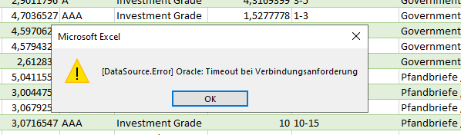

This type of error indicates that the query takes too long to be processed.

You could increase the time to process the query like this:

Got to the Source Data (in your selected Power Query) -> click Modify of the Source:

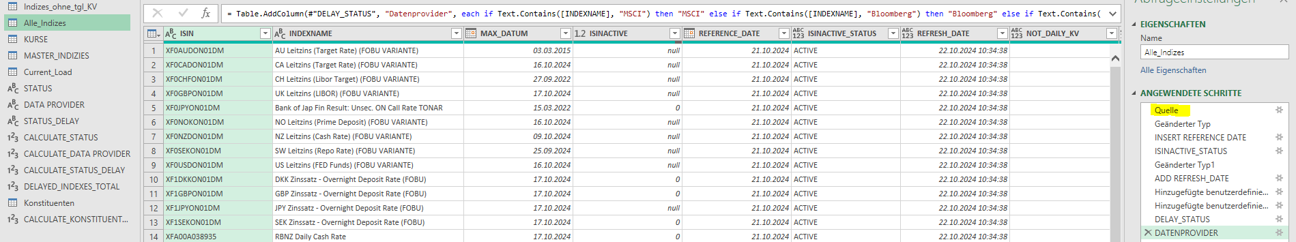

Insert the Time (in Minutes) to increase the Timeout Period:

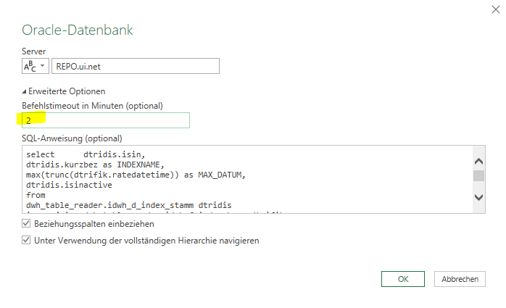

## Slow Loading of Data (when data are refreshed)

Go to The Power Query Editor Settings and uncheck “Download der Datenvorschau im Hintergrund “. It will improve the Data Load Performance

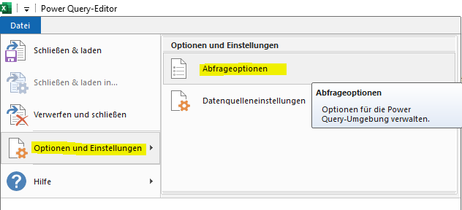

Ein Bild, das Text, Screenshot, Zahl, Software enthält.

## Delete Cache

It is a good practice to delete from time-to-time Cache in this Dashboard, especially if you notice very slow performance of Data Load. Go to The Power Query Editor Settings:



Ein Bild, das Text, Screenshot, Software, Webseite enthält.
